Bit addresses for I/O and RAM

RAM 128 divided into 3 partitions

- 32 bytes register Banks(Bank0 Bank1,Bank2,Bank3)

- 16 bytes for bit address for RAM

- 80 Bytes for Bit address for I/O

RAM 128k
32 Bytes | 16 Byes | 80Bytes Bit address
16 bytes for bit address for RAM

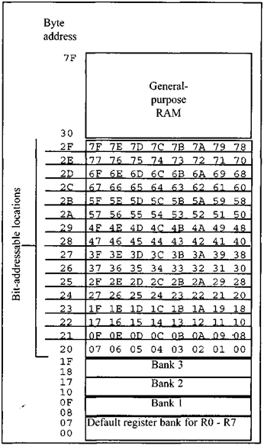
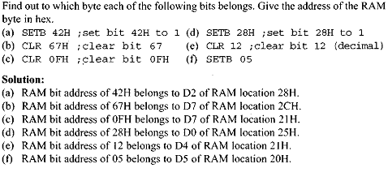
In order to avoid confusion regarding the addresses 00 – 7FH, the following two points must be noted.
- The 128 bytes of RAM have the byte addresses of 00 – 7FH and can be accessed in byte size using various addressing modes such as direct and register-indirect, as we have seen in
this chapter and previous chapters. These 128 bytes are accessed using byte-type instructions.
- The 16 bytes of RAM locations 20 – 2FH also have bit addresses of 00 - 7FH since 16 x 8 =128(00-7FH). In order to access these 128 bits of RAM locations and other bit-addressable space of 8051 individually, we can use only the single-bit instructions such as SETB.

80 Bytes for Bit address for I/O

4 Ports (P0,P1,P2,P3)

